CASE ANALYSIS OF P.A INAMDAR & ORS. V STATE OF MAHARASTRA & ORS.

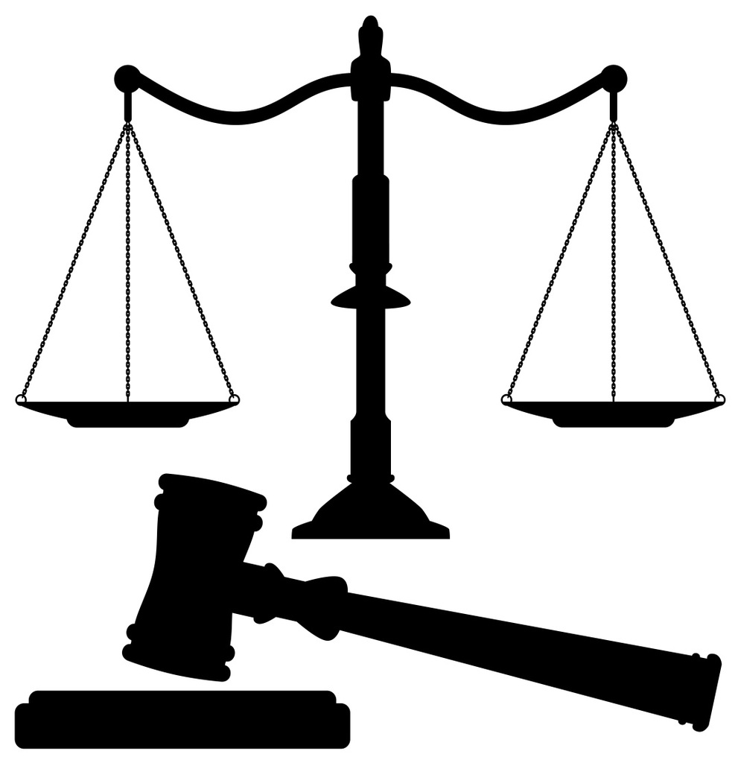
BY
DEYASHINI MONDAL
INTERN
1ST YEAR,
SYMBIOSIS LAW SCHOOL, PUNE
Mob- 9831031562
Gmail- mondal.deyashini@gmail.com

26th APRIL 2020
THE P.A INAMDAR CASE AND ITS IMPACT ON RERVATION SYTEM IN INDIA.
BACKGROUND
When we turn back time in history, we can see the origin of a prominent sort of discrimination based on caste which still exist in our society: Scheduled Caste (SC), Scheduled Tribe (ST) and Other Backward Classes (OBC) which primarily constitute 50% of the Indian population. Due to the belief which has come down from history that the ‘lower castes’ are impure by birth and association and also due to the occupation they practice like butchering, day laboring which led to them being distanced and socially and economically marginalized. The first-time recognition of this degrading discrimination was during British India where for the first-time positive discrimination can into picture for the three minority caste groups.
It was for the first in 1892 that special schools were established for the scheduled caste and then in 1944 a five-year budget 3,00,000 was set aside for these students. In 1919 a quota for political representation and hiring for civil service in 1934 was made for the SCs. In 1950, through the Indian Constitution, legal protection for the SC, ST and OBC groups were formalized and through Articles 16, 17,28 and 46 a foundation for affirmative action to protect the groups was introduced.
HISTORY OF RESERVATION SYSTEM IN INDIA
Taking into the historical account, the subject of reservation is a big one. A lot of opinions have been raised against the existing reservation policies after the Mondal Commission Report (1991) was accepted for the betterment of the weaker sections in higher education, government services. Acknowledging the position of foreign states, like Americans, were influenced by this experiment and “affirmative action” was introduced with an aim to reduce the discrimination against African-Americans and other ethnic minorities against the Native Americans in the 1960s. The ethnic minorities and those who are a victim of discrimination in countries like Europe, America and Great Britain are being considered to be given reservation or affirmative action for their upliftment and betterment.
It was during the last decades of the 19th century that the reservation system in Indian the time when the country could be divided into two main forms of governance, the British India and its 600 princely states. Among these several princely states, some of them were being progressive and eager to modernize by promoting education and industry in their kingdoms and also by ensuring unity among the people. For example: Mysore in South India and Baroda and Kolhapur in Western India. Thus, when we look into history it can be seen that reservation policies were introduced in these princely states.
With Ambedkar becoming the chairman of the Drafting committee of the Indian Constitution, the weaker sections of the society found a ray of light and make a political difference for them and give them so representation in the society. It was during the Communal Awarded 1935 that the question o f reservation was raised during the round table conferences in spite this meeting being opposed by Mahatma Gandhi. Ambedkar was appointed member of the Viceroy’s Executive Council and he submitted a memorandum titled, ‘On the Grievances of the Scheduled Castes’. This enabled the Scheduled Castes 8.5 percent reservation in central services and other facilities for the first time in the history of India in 1942.

As soon as the Constitution was adopted, the provision of the reservation was challenged by a writ petition filed in the High Court of Madras in the case of State of Madras v Champakam Dorairajan. It was brought before the Supreme Court of India. It was claimed that State of Madras was violating the provision of Article 29 (2) of the Constitution by fixing the proportion of students from each community that could be admitted in educational institutions. After getting independence, India has witnessed various landmark cases which has questioned the administration and the interests of the Scheduled caste and scheduled tribe and the other backward classes.
In 1962, the case of Balaji v Mysore was a landmark case where it was claimed the list of the backward classes were prepared only on the basis of their cate and this was said to be unconstitutional. the Supreme court thus struck down the Mysore Backward classes list. Similar questions were raised in the case of Chitralekha v State of Mysore. The Balaji case interpreted somewhat differently in this case.
In the case of Jayasree v State of Kerala, the logic of the Kerala high court which said that the economic backwardness played a vital role in the educational and social backwardness of these groups. In another case of State of Kerala v N H Thomas, the caste-based reservations were upheld by the Supreme court. It was also observed by the Apex Court that the aim of the Constitution was to eliminate the caste from the state affairs. Yet, some of the backward classes require reservation for the compensatory measures so the caste and ultimately be finished.
The acceptance and implementation of the Mandal Commission saw the rage and opposition of the Hindu upper caste students as well as the Supreme Court bar association. Uner the name iof Indra Sawhney, one of the practicing advocates of the Supreme Court, a writ petition against the above was brought. A discussion regarding the promotion policy of the scheduled caste was held and itws held that there shall be no reservation for them in times of promotion. Even after all the opposition faced by the Mandal commission reservation for the other backward classes was fixed at a 27% and was upheld which disappointed many of the upper caste Hindu citizens. Initially, the reservation was given to only the scheduled castes and scheduled tribe but from 1993, the other backward classes were also given a national level reservation. In the olden times there existed slogans like “religion in danger” but nowadays it can be seen that slogans have come up like “abolish reservation system because merit and efficiency is in danger.
FACTS
- Plaintiff raised the question before the court that whether there can exist reservation in private professional institutions
- It was opined by the Court that the State can’t impose its reservation policies on minority and non- minority unaided private institutions, including professional colleges.
- Maximum autonomy was conferred upon all unaided institution, minority and non-minority by Lahoti C.J.
- According to the learned judges, the government shall not impose such reservations upon such institutions.
- It was initially looked upon by the court that neither the policy of reservation can be enforced by the State nor can any percentage of quota in such a minority and non-minority unaided educational institution.
RULE
The Supreme Court passed an order for this judgement stating that there can’t be and state-based reservations to unaided educational institutions according to the existing provisions. Under Article 30(1) minority institutions are free to admit students which they want which may include students of non-minority groups as also members of their community from other States but both to a limited extent only and in such a process it shouldn’t happen that their minority educational institution status is lost. If they do so, they lose protection under the above-mentioned Article.
Therefore, in order to impose such state-based reservation on unaided private educational institutions, the Court had to bring about an amendment in the Constitution. It was further noted that according to Article 46 of the Constitution, the directive principles clearly state that that the State shall promote with special care the educational and economic interests of the weaker sections of the people and protect them from social injustice. In order to promote the development of education among the socially and educationally backward classes, they should have access not only to government aided institutions, but also to the unaided ones. Therefore a 5th clause was added to Article 15 with an aim to promote the educational advancement of the socially and educationally backward classes of citizens, the Scheduled Castes and the Scheduled Tribes through special provisions relating to admission of students belonging to these categories in all educational institutions, including private educational institutions, whether aided or unaided by the State.
Further it was added that nothing in this Article or in 19(1)(g) shall restrict the state from making any sort of special provisions relating to their admission including the private educational institutions, whether aided or unaided by the state, other than the minority educational institutions referred to clause 1 of Article 30. Therefore, a uniform reservation system was formed where 15% of the seats were reserved for Scheduled Caste, 7.5% for Scheduled Tribe and 27% of the seats must be reserved for the Other Backward Classes. Only exception was that this act did not apply to central educational institutions established in the tribal areas mentioned in the 6th Schedule of the Constitution.

ANALYSIS
Every landmark case has come into existence because of other important case laws which acted as a stepping stone for it. The two most important case laws with regards to this case are T.M.A. Pai Foundation & Ors. vs. State of Karnataka & Ors. and Islamic Academy of Edn. & Anr. Vs. State of Karnataka & Ors.
In case of the former in 2003, the Supreme Court bench decide the scope of the right of minorities to administer and establish educational institutions of their own choice as prescribed under Article 30(1) read with Article 29(2) of the Constitution. This was decided by a bench of 11 renowned judges. The majority opinion of 6 judges was that only the State could determine what status a religious and linguistic minority held those who will be put on a par in Article 30 which have to be considered State-wise.
However, the right under Article 30(1) cannot be such as to override the national interest or to prevent the Government from framing regulations in that behalf and any regulation framed in the national interest must necessarily apply to all educational institutions, whether run by the majority or the minority. Such a limitation must necessarily be read into Article 30. It must be noted that government regulations can’t ruin the minority character or make the right to establish or administer a mere illusion.
Although the right under Article 30(1) is not absolute or above the other provisions of the Constitution, some regulatory measures can be imposed in order to maintain educational standards and retain excellence in the professional institutions especially. In order to provide a proper academic atmosphere, some regulations or conditions generally for the welfare of the students and teachers may be made applicable as such provisions don’t interfere with the right of administration or management under the said article. Due to different interpretations of different high courts, the merit consideration at the apex court was highly divided in its opinion which eventually gave rise to subsequent questions.
The other important case is that of Islamic Academy of Edn. & Anr. Vs. State of Karnataka & Ors., where the apex court was efficient and speedy enough to take into consideration all the questions and ambiguities which have arisen from the previous judgement. Therefore a five judge bench was formed to answer the questions raised in the Pai foundation case. Through this the Pai foundation case was better understood, clarified and simplified thorguht the case of Islamic Academy of Education and Anr. v. State of Karnataka and Ors.. However, despite sincere efforts were made to clarify all the questions that had arisen during the Pai foundation case, the Islamic foundation case had its own short comings and therefore couldn’t serve the decided purpose.
A lot of questions has remained unanswered may have been raised after Pai foundation and Islamic Academy case. The Benches hearing individual cases though that they would finds an answer subsequently. It was declared by the judges that the issues already raised by the Pai foundation and the yet to open questions shall be answered by a larger Coram of judges than the 11 judged bench. The issues of the case as declared by the bench would be taken care of by posterity.
The 1st question raised in the Apex Court in the case of Islamic Academy of Education v State of Karnataka which was one of the biggest concerns was whether fees structure could be fixed by private unaided educational institutions on their own discretion. By clarifying the stand taken by the apex Court in the case of Pai Foundation about the fee structure and also taking into consideration the interests of the educational institutions in order to earn surplus and to prevent commercialization of education, the apex court taking into consideration its its findings, summarizes its case as follows;
It was held per Khare, CJ. (for himself and for Variava, Balkrishnan and Pasayat, JJ) that as far as the fee structure is concerned, it had been clear by the majority judgement of the Pai foundation case that there can be no fixed or rigid payment structure made by the government. Each and every institute must have the freedom to decide its fee structure taking into consideration the amount of funds that needs to be raised in order to run the particular institution and provide the student with their necessary facilities. Also, a surplus amount of money has to be raised in order to ensure the betterment and growth of the educational institution. Again, it was told that the decision on the fees of the private unaided institution must be left to their discretion as they are not necessarily funded by the government in anyway. Each institute is entitled to have its own fee structure. It must be ensured that the fees structure for each institute is fixed in such a way that the infrastructure available, the investments made, the salaries paid to the staff and teachers, the future plans to expand or improve the institution are kept in mind. It must be thus noted that according to the majority judgement in the Pai foundation, education is essentially a charitable deed in nature. Thus the excess or surplus raised from the fees paid must be used only for the benefits of that educational institution. The surplus cant be used for any other purpose or for personal gains or any other nosiness a=matter or enterprise.
It was noticed by the Court that there existed a lot of statues and regulations which governed the fixation of fees and thus the court instructed the respective state governments to form a committee which will be headed by a retired High Court judge to be nominated by the Chief Justice of the State to look into the matters of fees structure and approve them or to propose the appropriate fee structure which could be charged by the institution.
In the present case of Inamdar, the court classified the aggrieved persons into two classes i.e. the minority and the non-minority institutions imparting professional education. The third issue raised in the apex court in this case was about the fees structure of such institutions. It was opined in the case of Inamdar regarding the regulation fee that;
It was within the scope of Article 30(1) of the Constitution that to set a reasonable fee structure is also a component of the Right to establish and administer an institution. Every institute has been given the freedom to devise its own fee structure subject to a few limitations that there cant be any sort of profiting and no capitation fee can be charged directly or indirectly or in any other form.

JUDGEMENT
The Court in this case brought about the 44th amendment to the constitution and included the 5th clause in Article 15 of the Indian Constitution. This clause goes ahead an allows caste-based reservation in not only the government aided institutions but also the ones which are privately run, can be minority or non- minority institutions.
This was done in order to assure that the socially and educationally backward classes are not excluded from any sort of educational facilities just because there exist no provisions or recognition for their benefit.
INSIGHT
It is true that if each and every citizen of India get political equality, it will result in everyone getting what they truly deserve. But many people view it in a different way. They say that in reality when the seats are in short supply, a lot individuals who are deserving, end up not getting admission into the places they truly are capable of. The advocates of reservation claim that this would also be the case if there existed no quota seats for the backward classes. It is pathetic that people think that political equality can be gained when the number of seats match the number of only does who deserve to get the seats and when the problem of economic inequality is dealt with in the society.
Some people feel that reservation can be acceptable on economic criteria and not on the basis of caste. What these people fail to under is that every country has poor. Various schemes already exist for their betterment. The point they miss out is that Dr. B.R Ambedkar did not bring this into picture because of economic disparity. It was brought for the upliftment of the people who were called and treated as untouchables just a few decades ago. This was created for the people who because of their caste, were not allowed access to education. It was created for the community whose names were taken in a distasteful manner and for whom Manu had laid down crude laws if they tried to think of themselves as human beings.
Another point the opposing lot say is that by asking for the caste, we are eventually dividing India. This caste has become our identity. Almost 50% if not more do not marry their children to lower caste individuals. Students who go through reservation as still looked down upon due to their castes and eventually hampering their mental health. This leads to suicides when the student can’t handle anymore of the pathetic way, they are treated in.
By implementing the reservation system it is believed that hatred towards castes will increase which is already leading to tension in classrooms of IITs IIMs, Law Schools etc. Taking into consideration the fees charged for the SCs/STs in the law schools, there exists no much difference. If we are trying to uplift the economically poor, how do they afford to pay fees equivalent to someone who has a lot of funds?

If a reservation less country has to been made, a caste-less country is also required. In foreign countries where there exists no concept of caste, people are treated equally and there are schemes which help the poor to some extent. But no one discriminates on the basis of their “castes” when their children want to get married. Our country is a diverse one and in order to remove reservation, respect for the Scheduled Castes and Scheduled Tribes must be inflicted, if not the people must be denied from using surnames which clearly distinguish based on caste.

CONCLUSION
Dr. BR Ambedkar in his mind pictured a casteless and classless society and therefore the Constitution. In order to uplift the downtrodden people and provide them an equal status, provisions for reservation in education and employment were made. Initially the reservation was only introduced for Scheduled Caste and Scheduled Tribe. Many voices were raised from time to time to give special reservation of the Other Backward Classes and citizens of the north-east states. It has been enshrined under Article 15 that reservation for socially and educationally backward classes i.e. the SC, ST and OBC. The desire for government jobs is one of the main reasons by the demand for reservation and its policy is promoted by the state and central government.
No citizen must be deprived of education in any institution of the country, be it government or private. This judgement is in the right direction and has allowed to give more educational opportunities for the development and increase the forwardness of this the rather backward classes.
SUGGESTIONS
I am all in the favor of having laws and rules to make sure that the underprivileged get more opportunities and it’s the duty of the government to think about that. The Caste system is one of the greatest social evils plaguing Indian today. It is acting as a powerful social and political divisive force at a time when it is essential for us to stay united to face the challenges of the global world order. It is a curse that must be speedily eradicated if we wish to progress. But indeed, it will stand' effaced in a decade or two, for its basis has been destroyed. In fact, it will be destroyed and is being destroyed in India by the advance of technology, through people’s struggle and inter-caste marriages.
As regards the advance of technology, it is true that in modern industrial society, the division of labor cannot be on the basis of one’s birth, but on the basis of technical skills. Hence, industrialization destroys the caste system. As regards people’s struggles, these are in fact going on everywhere in view of the harsh economic conditions in India marked by price rise, unemployment and so on. People in India are realizing that united they stand and divided they fall, and that caste is certainly a dividing force. Inter caste marriage should be encouraged to destroy the caste system in the national interest.
Looking into the condition of the present caste system in India and the importance it carries in the lives of the people, it can be concluded that the caste system in the minds of the people will not end in the near future. The development of caste-based matrimonial sites is added. As established in the research paper, there is no use of removing the reservation system by not removing the caste system. If by removing the reservation system the population believes that equality will finally prevail, they are thinking wrong. By removing this system, the upper caste will once again enjoy their exaggerated rights and the caste-based discrimination and undermining of the lower castes will continue at a much higher pace. Therefore, it is submitted that the reservation system plays a vital role in providing equal opportunities to each citizen of the country and that it should be removed only when the people of the society forget what a caste system is.
REFERNCES
- Shanbhag, Vagish Kumarl. 2017. “National Eligibility Cum Entrance Test Should Not Be Considered as Sole Criteria for Gaining Entry into Medical Education in India.” Journal of Education and Ethics in Dentistry 7 (1): 1.
- Shrikhande, Anuradha V., Aishwarya Arjunan, Amit Agarwal, Aarti Dani, Jayashri Tijare, Elizabeth Gettig, and Lakshmanan Krishnamurti. 2014. “Prevalence of the βSGene Among Scheduled Castes, Scheduled Tribes and Other Backward Class Groups in Central India.” Hemoglobin 38 (4): 230–35.
- https://targetstudy.com/ , Impact of reservation on equality of education. Indian Express (11th feb 2016), Article on reservation.
- India Today (2007), Article on private educational institutions to have reservation. International Journal of Pure and Applied Mathematics Special Issue 4220
- Dr.Lakshmi T and Rajeshkumar S , March. 2018. “In Vitro Evaluation of Anticariogenic Activity of Acacia Catechu against Selected Microbes”, International Research Journal of Multidisciplinary Science & Technology, Volume No. 3 , Issue No. 3, P.No 20-25.
- Trishala A , Lakshmi T and Rajeshkumar S, April 2018.“ Physicochemical profile of Acacia catechu bark extract –An In vitro study”, International Research Journal of Multidisciplinary Science & Technology, Volume No. 3 , Issue No. 4, P.No 26-30.

State of Madras v Champakam Dorairajan [1951] SC 226
Balaji v State of Mysore [1963] SC 649
Jayasree v State of Kerala [1976] SC 2381
State of Kerala v N H Thomas [1976] AIR 490,
India legal S, “Can Reservations And India Bloom Together” (Legal Service India) <http://www.legalserviceindia.com/articles/res_in.htm> accessed May 3, 2020
T.M.A. Pai Foundation & Ors. vs. State of Karnataka [2003] SC 355
Islamic Academy of Edn. & Anr. Vs. State of Karnataka & Ors. [2002] (8) SCC 481

